HomeRunBusiness Requirements Document

short line

Victoria Lynch 18988156

Steph Goode 18977812

Sasha Zauchenberger 19157894

Amy Broughton 19125240

18th August 2017

Table Of Contents

**Version Control** **4**

Revision History 4

RACI Chart 5

**Executive Summary** **6**

Overview 6

Background 6

Objectives 7

Requirements 7

Proposed Strategy 8

**Project Scope** **9**

Included in Scope 9

Excluded from Scope 9

Constraints 10

Functional Requirements 10

Timeline 11

Measures of Project Success 11

**Risk Analysis** **12**

**Business Case** **13**

Issues 13

Proposed Solution 13

Approach for Solution 14

Justification 14

Organizational Impacts 15

Tools needed 15

Processes 15

Roles and responsibilities 15

Project Description 16

Project Assumptions 16

Cost Benefit Analysis 17

**Non-functional Requirements** **18**

Performance Requirements 18

Usability Requirements 18

Security Requirements 19

Software Requirements 19

Modifiability 19

Interface Requirements 19

Availability requirements 20

Assumptions / Constraints 20

Compliance Requirements 20

**Business Use Case** **21**

Business Use Case Descriptions 22

Communication Between Residents 22

Communication Between Home Owners Association 22

Report Problem 23

**Actors** **24**

Workers 24

Business Actors 24

Other Systems 25

Role Map 26

**User Requirements** **27**

System-Use Case Diagrams 27

Communication Between Residents 27

Communication with Home Owners Association 28

Report Problem 29

System Use Case Descriptions and Wireframes 30

Communication Between Residents 30

Private Message 30

Interact on Chat Forum 32

Discuss Conflict 34

Consult Home Owners Association 36

Create Advertisement 37

Communication with Home Owners Association 39

Create Resident Account 39

Confirm Account 41

Edit Account 43

Load Tenants Balances 45

View Balances 47

Delete Resident/Tenants Account 48

Receive General Notifications 50

View Home Owners Associations Contact Details 52

Raise an Enquiry 54

Handle Enquiry 56

Passes On Enquiry 57

Create Notice 59

Report Problem 61

Lodge Support Ticket 61

Categorize Support Ticket 63

Receive Support Ticket 64

Inform of Maintenance Date 65

Confirm Date 66

Wireframe Text Descriptions 67

**State Machine Diagrams** **74**

Support Ticket 74

User Profile 75

Notice 76

Enquiry 77

**Class Diagram** **78**

Assumptions 79

**Deployment Plan** **80**

Training 80

Conversion 80

Scheduling of Jobs 80

Rollout 81

End-User Procedures 81

Post Implementation Follow Up 81

**Sign-Off** **82**

**Glossary** **83**

**External References** **85**

# Version Control

## **Revision History**

This type of version control is widely used for software development. It has an emphasis on speed, data integrity and support for distributed workflows.

|  |  |  |  |  |
| --- | --- | --- | --- | --- |
| Version # | Date | Authorization | Responsibility(Author) | Description |
| 1.0 | 10/08 | Property Developer | IT Developer | Initial Draft |
|  |  |  |  |  |

## **RACI Chart**

Codes Used in RACI Chart

* (Authorize)

R (Responsible)

A (Accountable)

S (Supports)

C (Consulted)

I (Informed)

|  |  |  |  |  |  |  |  |
| --- | --- | --- | --- | --- | --- | --- | --- |
| Name | Position | * | R | A | S | C | I |
| Amy Broughton | Property Developer | X |  |  |  |  | X |
| Victoria Lynch | IT developer |  | X |  |  | X |  |
| Sasha Zauchenberger | Home Owners’ Association |  |  | X |  |  | X |
| Stephanie Goode | User |  |  |  |  | X |  |
| Harry Potter | Project Manager |  |  | X |  |  | X |

# Executive Summary

## **Overview**

HomeRun is a mobile application that will be developed for a property developer who owns 6 student apartment buildings in Stellenbosch. The purpose of this application is to enable efficient communication between the Home Owners’ Association (HOA) and tenants and residents of the buildings. The application is to be the central platform allowing the HOA to keep track of and deal with a wide range of issues in the apartment buildings. The HOA will be allowed to manage all user profiles on the system which will ensure that they have control over the buildings. Although HomeRun is being built for the HOA’s convenience, it is also going to benefit the residents and tenants of the buildings. They can communicate amongst each other on a public forum, create smaller chat groups and send private messages to one another. HomeRun will also allow users to raise enquiries, report problems and access the HOA’s contact details. In addition to this functionality, an extra feature includes an advertisement board, where users can post advertisements to sell their belongings.

## **Background**

The creation of this application was a promise made by the property developer to the HOA upon sale of the apartment buildings. HomeRun should enable easy and centralised management for the HOA. It will allow them to manage daily operations in an efficient manner. When a resident or tenant has a problem, they will be able to create a support ticket for the HOA to deal with. This would benefit them as it is a better alternative to the standard HOA communication system, which involves many emails, phone calls and frustration. The property developer believes that it is important that residents and tenants can communicate amongst each other to create a closer and safer community. Both parties can therefore benefit from HomeRun, which demonstrates a demand for the product. The application will ensure that all users are always informed and up to date with current problems.

## **Objectives**

The main objective of HomeRun is to ensure smooth management and fast problem resolution by the HOA. The norm for communication between HOA’s and residents is inefficient as it involves many phone calls, emails and uncertainty. HomeRun can solve this problem by using support tickets to track problems and complaints. Easy communication forms that can target individuals, separate buildings and the whole community will also achieve this objective. An aim of the project is to provide a platform where residents and tenants can communicate safely. HomeRun will achieve this objective through the use of a public chat room, private messaging and group messaging. Another objective that HomeRun wishes to achieve is making sure that everyone is treated fairly and ensuring transparent information. Since all messages and support tickets are loaded onto the application, they can be referred back to in situations of conflict. HomeRun will also have a user friendly interface to ensure comfortable usage by the HOA, tenants, residents and the property developer.

## **Requirements**

The application’s main focus is to provide a platform for effective and efficient communication between the HOA and residents and tenants. As mentioned above, the HOA is responsible for adding users to the system. The HOA will also use the application to delete user profiles if the residents move out or to simply view user profiles for monitoring purposes. The system should allow users to view contact information of managers in the HOA. Therefore, they should be allowed to contact the HOA externally or by raising an enquiry through the application. HomeRun will show the HOA who the enquiry is from and will also display the user’s profile. The state of a support ticket must be tracked by the system. The HOA manager dealing with the support ticket as well as the user who lodged it shall be updated whenever the state changes. The application will safeguard user privacy by not publically displaying personal information. The users can however change their privacy settings if they want other residents to, for example, see which building and room they live in. The application will provide a public chat interface that all residents, tenants and the property developer can view and participate in. An additional feature for users is an advertisement board which will display products that other users are selling and will also allow users to create, post and edit their own advertisements.

## **Proposed Strategy**

This is the process of understanding and conceptualizing the application requirements in order to begin the implementation phase. Investigation into the best approach and software development methods will be undertaken. The development team will analyse all of the business cases thoroughly, find solutions and turn the findings into a fully functional mobile application. This iterative process of programming, designing and testing shall eventually produce the product that is required.

# Project Scope

HomeRun is designed to be used by residents, tenants, the HOA and the property developer. The business areas that are included and excluded in the scope of the project are mentioned below.

## **Included in Scope**

HomeRun will be able to facilitate communication between residents through the use of a public chat room and personal messages. The application will allow residents to communicate with the HOA. Residents and tenants will also be able to view the contact information of managers in the HOA.

The application will allow residents and tenants to lodge support tickets when they wish to complain about maintenance issues, legal issues or any other issues. The HOA will deal with these support tickets. Residents and tenants may also raise enquiries if they wish to find out more information about an issue.

The HOA will be responsible for the management of user accounts. They will have the power to create, monitor and delete user information using the application. The HOA should also be responsible for keeping tenant and resident balances up to date.

Tenants and residents should be able to use the application to post advertisements for any belongings that they wish to sell. The application will send users notifications when it needs their attention.

## **Excluded from Scope**

A business aspect that is not included in HomeRun is the payment processes, with regards to rent and levies. The application will only display the amounts owed by the tenant. Actual payment transactions will occur externally.

When external support staff is required to fix a maintenance issue, communication and scheduling is organized externally since service people do not have access to the application.

## **Constraints**

There are many constraints which can limit the success of this project. Time is a significant constraint as there is a strict deadline for the project, which is to be completed by 16 October 2017. This deadline is not flexible which also makes planning important during the implementation phase.

The creators are students and therefore have limited resources to create the application, even though adequate resources are supplied by the university. Funds are not available to purchase certain software programs to enhance development. Restricted versions of some software therefore have to be used. The development team only consists of 4 members. Since the creation of this application is for learning purposes, limits on programming knowledge exist.

## **Functional Requirements**

The application must allow:

* The HOA to add and delete users to the system and manage their profiles.
* Each user to edit their profile information, including their security settings.
* The HOA to change the status of a support ticket and communicate it to the resident/tenant.
* All users to view and contribute to the public chat forum.
* Users to send private messages to other users.
* Residents and tenants to create small chat groups.
* Users to view the advertisement board as well as post advertisements on it.
* Residents and tenants to raise enquiries with the HOA.

## **Timeline**

In this section of the BRD, a timeline is shown to depict all the relevant start dates and completion dates. This is useful because it gives the creators set goals.

|  |  |  |
| --- | --- | --- |
| **Section** | **Start Date** | **Completion Date** |
| JAD Sessions | 25th July | 25th July |
| Documentation | 17th July | 18th August |
| System Implementation | 20th August | 16th October |

## **Measures of Project Success**

The success of the project will be determined by how well the application satisfies user requirements and if it processes and manages business and systems cases successfully. Measures of the project’s success include:

* The property developer’s satisfaction of the product.
* The project’s completion date – must be before the deadline.
* The budget used during development – should not be exceeded.
* How user friendly the application is.
* How well the application allows the HOA to conduct daily operations.

# 

# 

# Risk Analysis

|  |  |  |  |
| --- | --- | --- | --- |
| **Risk ID** | **Description** | **Likelihood Of Occurrence** | **Strategy** |
| Hacking | Unauthorized intrusion into the system. | Low | Put security measures in place to  avoid hacking from occurring. |
| System Bugs | An error or flaw in the program that causes it to produce an incorrect or unexpected result, or to behave in unintended ways. | High | Write system tests to make sure that all  functions run and operate as intended |
| Data Loss | An error condition in information systems in which information is destroyed by failures or neglect in storage, transmission, or processing. | Low | Implement backup and disaster recovery  equipment and processes to prevent data  loss or restore lost data. |
| Server Crashes | A crash occurs when the server stops functioning properly and exits. | Low | Ensure there are backup systems to hold data in case  of crashes |
| Cyber Attack | An attempt by hackers to damage or destroy a system. | Low | Keep systems up to date and install anti-virus  software. |
| Data Breach | An incident in which sensitive, protected or confidential data has been viewed, stolen or used by an individual unauthorized. | Low | Institute end user security awareness. Training helps  eliminate mistakes that could lead to a breach,  as well as helps user notice odd behavior by  malicious insiders or fraudsters. |
| Local Storage | Although often used to improve performance, local storage can lead to serious security flaws especially when dealing with sensitive information. | High | Implement further security measures or encryption to  prevent users from being able to modify or edit  important data. |
| Heavy Design | Giving designers freedom to create eye-candy interfaces without performance in mind often leads to late design changes and possible delays. | High | The developer should clearly define the application  performance boundaries, and then the designer  with those boundaries in mind will create a design  that fit specifications. |

# Business Case

## **Issues**

HomeRun is currently using a paper based and a simple computer based system to contact Tenants and Residents. This type of system has proven to be inefficient and ineffective. HomeRun want to be able to effectively communicate with each tenant as well as tenants as a collective. They propose to do this through a mobile application that has cross functionality, allowing tenants, residents and the Home Owners’ Association to communicate quickly to solve any issues or requests.

## **Proposed Solution**

HomeRun is an application that is being developed for a property developer that has recently purchased six buildings, each with ten units, in the Stellenbosch area. The property developer has sold this development and has promised a mobile application for effective and efficient communication between the Home Owners’ Association and Tenants. The aim of HomeRun is that it should allow direct communication for individual tenants as well as provide information about and to the tenants as a collective. The tenants will be able to lodge support tickets, request clarification on inquiries, see balances paid and pending as well as support communication between residents. These tasks will be completed quickly and efficiently. The mobile application will create effective and efficient lines of communication to all parties who are influenced by the application.

This mobile application will allow the HOA to increase its customer service towards residents and tenants by making it easier for them to communicate. It will reduce the workload for the Home Owners’ association as tasks will be completed on one application which in turn will reduce overhead costs. This real time access from all stakeholders reduces errors and improves cycle time of an issue being fixed.

## **Approach for Solution**

The mobile application has been evaluated and recommended as the most effective and efficient technology in order to increase the efficiency of communication between the tenants, residents and the Home Owners’ Association. It will also reduce overhead cost and increase efficiency. The application will be built using a framework which makes use of python, HTML and CSS for the mobile application design and JavaScript and SQLite to handle the functionality and database requirements.

The Home Owners’ Association will be provided with adequate training in order to utilize the application to its full potential. This will include using the administrative function to contact the tenants and residents as well as create user profiles and load balances. The mobile application will be compatible with other IT platforms in order to be accessible to everyone.

## **Justification**

Using a mobile based application and allowing the Home Owners’ Association to take greater responsibility for administrative tasks will result in faster and more accurate interactions between all stakeholders. The mobile application will allow the system to be accessible 24/7 and create a smoother more efficient process in comminuting with the HOA. Essentially, in the long term this will lower costs spent on administrative tasks and increase customer service due to greater functionality and efficient communication. When testing the benefits of HomeRun, it was found that there will be a

* 25% reduction with overhead cost within the first 18 months.
* 60% increase in customer satisfaction within the first 12 months.
* 50% decrease in the time spent on average communication and solving tenants issues and requirements.

## **Organizational Impacts**

By designing and implementing a mobile application there will be a number of effects on the HOA. HomeRun will have to follow a number of set rules of how the HOA will adapt to the new system. These will be described based on the tools, processes, roles and responsibilities that will be needed to implement the system.

### **Tools needed**

The old system of using emails and paper will be phased out, and all information will be transcribed into an electronic version. The IT manager will have responsibility over this process.

### **Processes**

The new system will allow a tenant or resident to directly communicate with the Home Owners’ Association. If a problem or enquiry arises it will be logged, recorded and resolved on the mobile application. This will be significantly faster than a paper based system. The Home Owners’ Association will be able to organize, sort and resolve issues efficiently and faster. General communication, such as notifications to the tenants, will be communicated on the application. Both the tenants and the HOA will be able to access this communication.

### **Roles and responsibilities**

The Home Owners’ Association will have the main responsibility of ensuring that the application is being run efficiently and effectively. The HOA will be able to add and remove tenants on the application as well as handle all issues and enquiries. By transferring the system to a mobile application it will increase the efficiency and turnover of the problem solving/ communication between the stakeholders.

Tenants and residents will have the responsibility of informing the HOA of issues and enquiries as well as actively participating on the application.

## **Project Description**

The Mobile application will allow the HOA to continuously and instantly update the system to inform tenants of changes and issues that may be occurring with regards to the six buildings. Simultaneously, the tenant or resident will be able to log-on to the application using a username and password provided by the HOA and create a profile which other tenants and residents will be able to view. Tenants can communicate between each other as well as to the HOA. A tenant can lodge a support ticket to inform the HOA of an issue with regards to the building. The HOA will receive this message and handle the issue accordingly. The application will also house the ability to send group notification, where all tenants or residents will be able to view the notification. A Tenants will be able to receive information regarding the current balances on rent. Residents will not be able to view the balance owed. When a tenant or resident contract has ended the HOA will use the application to delete their account for security purposes.

### **Project Assumptions**

The following assumptions apply to the HomeRun mobile application:

* The Home Owners’ Association will be comprehensively trained in how to operate the application.
* Funding is available for purchasing hardware and software, funding the team to create the application and to train the HOA.
* The mobile application is supported and has been approved by the property developer and the IT technician
* The application will have the appropriate security to ensure the user's safety.

## 

## 

## **Cost Benefit Analysis**

The cost analysis describes the benefits that HomeRun will see due to the implementation of this mobile application.

|  |  |  |
| --- | --- | --- |
| **Action** | **Description** | **First year cost or anticipated savings (-)** |
| Creation of a mobile application. | Initial Investment for HomeRun | R500 000.00 |
| HOA training | The cost of training the Home Owners Association to be able to use the system | R1000.00 |
| Software Installation | The cost to install the software. | R100 000.00 |
| System Maintenance | The system may develop viruses, and my crash due to user traffic. | R100 000.00 |
| Trade off Savings from a paper system | HomeRun in the long term will save money using a more efficient and effective system | (R150 000.00) |
| Net Savings (Year one) |  | R551 000.00 |

# 

# 

# Non-functional Requirements

## **Performance Requirements**

Performance requirements refer to the system’s speed.

* **Stress Requirements**

The system must be able to support 150 users accessing the applications functions simultaneously.

* **Response-Time Requirements**

The maximum allowable wait time from the moment the user submits a request until the system comes back with a response is 5 seconds. For example, the time taken to click and change from one page to another.

* **Throughput Requirements**

Throughput requirements describe the number of transactions per unit of time that the system must be able to process. HomeRun must be able to process 150 transactions per 5 seconds.

## **Usability Requirements**

A new user (resident or tenant) to the application will be sent an email containing instructions on how to use HomeRun. The application has been designed to be user friendly in order to reduce the usability training time.

However, the HOA is required to complete two hours of training. They must be able to complete the following functions without assistance:

* Upload/ download financial statements to each tenant’s profile
* Forward messages and queries to the property developer and support staff
* Handle mass amounts of communication on the applications efficiently and effectively.
* Create new profiles for residents and tenants.

The HOA need to adhere to a high level of standards and complete professionalism free of error.

## **Security Requirements**

There have been no specific security requirements specified, however antivirus software, data backup storage and systems tests will be implemented to reduce the risk of a security breach.

## **Software Requirements**

The software is required to create a communicative interface between the HOA and the tenants and residents. It must have a dashboard for each user to perform their required tasks. The application must provide a way for users to be able to communicate amongst each other and with all other stakeholders identifies in the business use cases. All problems and inquiries should be identified and followed through using the system.

## **Modifiability**

The system will be able to be modified depending on problems that may arise in the future. New functions can be implemented depending on changing requirements and the adaptability of HomeRun after the post-implementation follow up.

## **Interface Requirements**

The system must have a login interface for all users. The property developer will be able to create accounts for the HOA members. The HOA will be able to create accounts for residents and tenants. The residents and tenants will be able to log-in to the interface and use its functions.

## **Availability requirements**

The mobile application must be fully functional 24/7, although enquiries and complaints that involve the HOA may be completed during working hours, functions such as communication chat forums between residents must always be active.

## **Assumptions / Constraints**

Each individual using the application is required to has a smartphone or smart device where they are able to download the application. The individual using the application must be connected to the internet in order to complete specific tasks.

## **Compliance Requirements**

The system must comply with the specified constraints within the business case.

# 

# Business Use Case

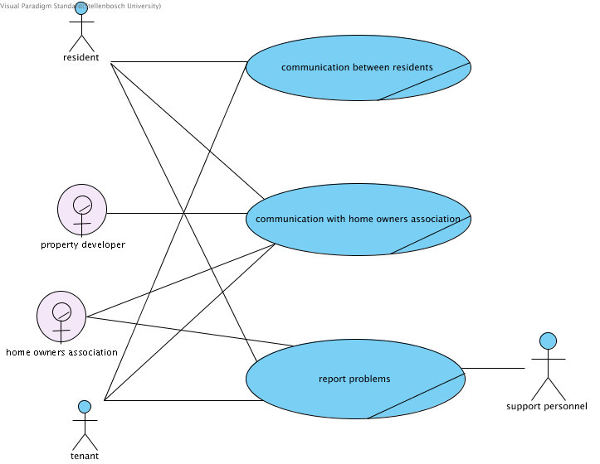

## **Business Use Case Descriptions**

### **Communication Between Residents**

## 

### **Communication Between Home Owners Association**

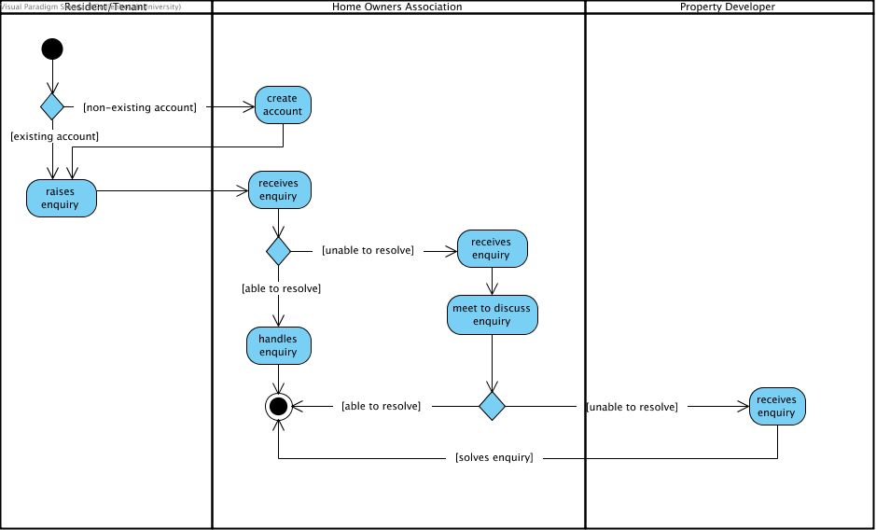

### **Report Problem**

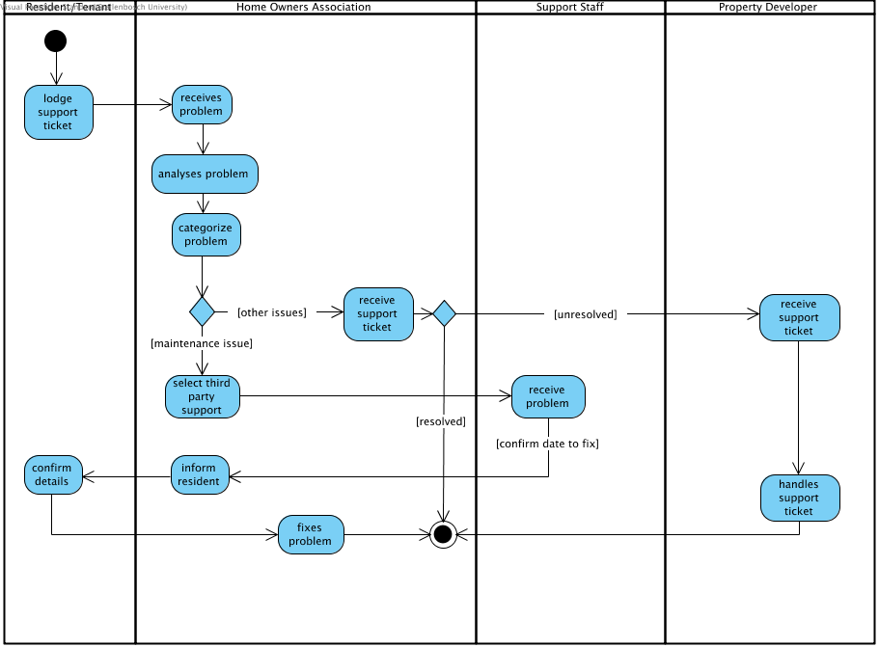

# 

# 

# 

# 

# Actors

In this section of the BRD, all the relevant actors are described. The actors include all people, organizations and other entities. An actor is someone that interacts with the business and the IT system.

## **Workers**

Workers are stakeholders who act within the business and carry out all business use cases.

|  |  |
| --- | --- |
| **Position** | **Impact on the Project** |
| Property Developer | Large impact. The system is developed according to this workers needs. It must made to suit the property developer and contain functions that simplify this worker's business needs. The system would not be created if it was not for this worker. |
| Home Owners’ Association | Significant impact. This worker uses the system the most, therefore it should be easy to use for them. It should also be able to facilitate all of this workers requirements. The system should make this worker’s tasks simpler and not create extra administration work for them. |

## 

## **Business Actors**

Business Actors are parties that are external to the business but still interact with it.

|  |  |
| --- | --- |
| **Actor** | **Impact on the Project** |
| Resident | Little to medium impact. This actor does not influence how the system is created as they only use it while they live in the relevant buildings. However, the system should still make their lives easier and add value. |
| Tenant | Little to medium impact. This actor does not influence how the system is created as they only use it while they live in the relevant buildings. However, the system should still make their lives easier and add value. |
| Support Personnel | Little impact. Support personnel do not have access to the system and are contacted privately. |

## **Other Systems**

Other systems are any systems that are affected by the project or that are linked to the proposed system.

|  |  |
| --- | --- |
| **System** | **Impact on the Project** |
| Existing applications on users device | Little impact due to the fact that the application runs without interference from these existing applications. |

## **Role Map**

# 

# 

# 

# 

# 

# 

# 

# 

# 

# 

# 

# 

# User Requirements

## **System-Use Case Diagrams**

### **Communication Between Residents**

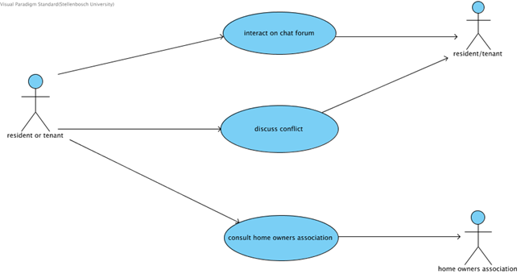

### **Communication with Home Owners Association**

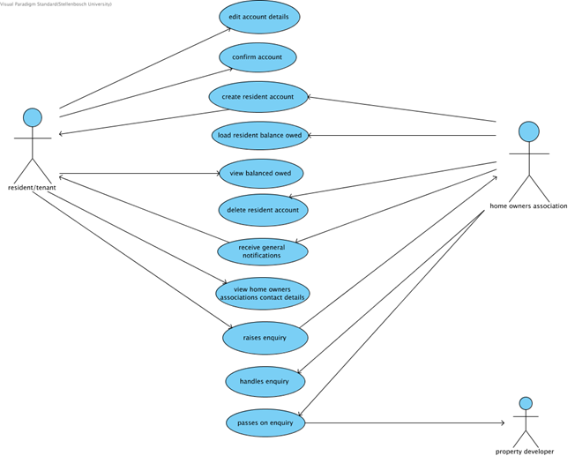

### **Report Problem**

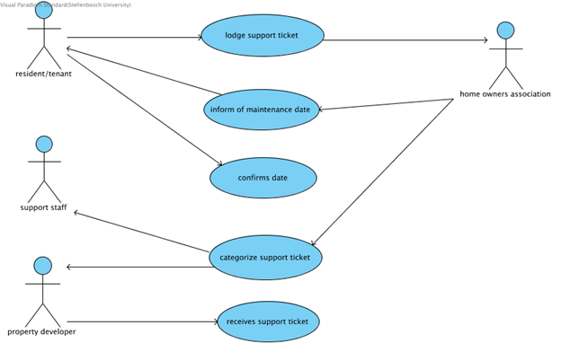

## **System Use Case Descriptions and Wireframes**

### **Communication Between Residents**

#### Private Message

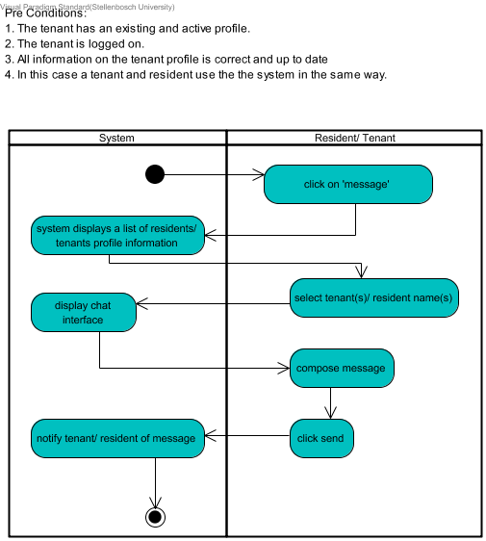

#### 

#### Macintosh HD:Users:sashazee:Desktop:Screen Shot 2017-08-10 at 10.56.34.pngMacintosh HD:Users:sashazee:Desktop:Screen Shot 2017-08-09 at 01.04.36.png

#### 

#### 

#### 

#### 

#### 

#### 

#### 

#### 

#### 

#### 

#### 

#### 

#### 

#### 

#### 

#### 

#### 

#### 

#### 

#### 

#### 

#### 

#### Interact on Chat Forum

#### Macintosh HD:Users:sashazee:Desktop:Screen Shot 2017-08-09 at 21.25.09.pngMacintosh HD:Users:sashazee:Desktop:Screen Shot 2017-08-09 at 21.25.48.png

#### 

#### 

#### 

#### 

#### 

#### 

#### 

#### 

#### 

#### 

#### 

#### Macintosh HD:Users:sashazee:Desktop:Screen Shot 2017-08-09 at 21.26.04.pngMacintosh HD:Users:sashazee:Desktop:Screen Shot 2017-08-09 at 21.25.19.png

#### 

#### 

#### 

#### 

#### 

#### 

#### 

#### 

#### 

#### 

#### 

#### Discuss Conflict

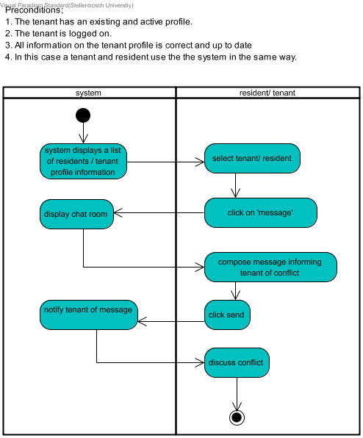

#### Macintosh HD:Users:sashazee:Desktop:Screen Shot 2017-08-09 at 01.04.36.pngMacintosh HD:Users:sashazee:Desktop:Screen Shot 2017-08-10 at 11.13.58.png

#### 

#### 

#### 

#### 

#### 

#### 

#### 

#### 

#### 

#### 

#### 

#### 

#### Macintosh HD:Users:sashazee:Desktop:Screen Shot 2017-08-10 at 11.26.13.png

#### 

#### 

#### 

#### 

#### 

#### 

#### Consult Home Owners Association

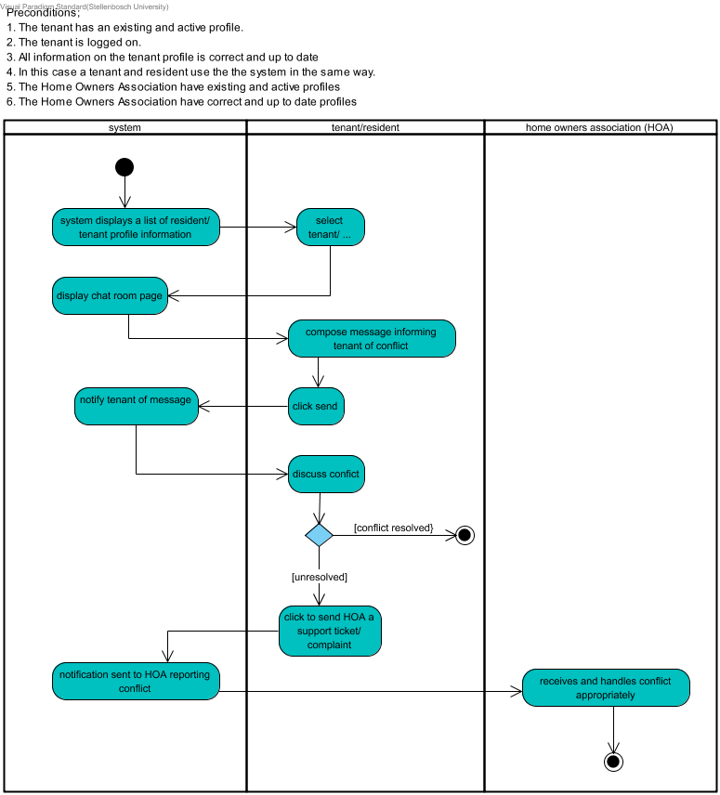

#### Create Advertisement

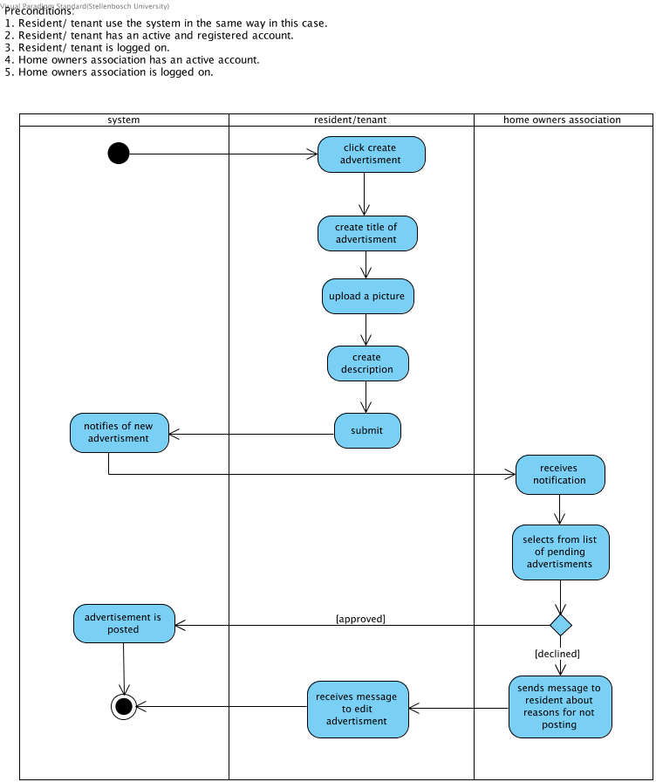

### Macintosh HD:Users:sashazee:Desktop:Screen Shot 2017-08-11 at 15.08.18.pngMacintosh HD:Users:sashazee:Desktop:Screen Shot 2017-08-11 at 15.08.29.png

### 

### 

### 

### 

### 

### 

### 

### 

### 

### 

### 

### 

### 

### 

### 

### 

### 

### 

### 

### 

### 

### **Communication with Home Owners Association**

#### Create Resident Account

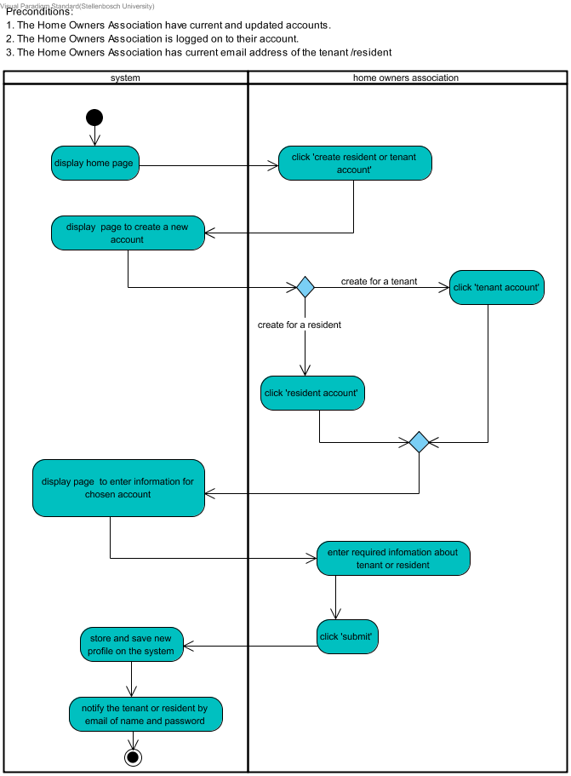

#### Macintosh HD:Users:sashazee:Desktop:Screen Shot 2017-08-09 at 20.45.16.png

#### 

#### 

#### 

#### 

#### 

#### 

#### 

#### 

#### 

#### 

#### 

#### 

#### 

#### 

#### 

#### 

#### 

#### 

#### 

#### 

#### 

#### 

#### 

#### Confirm Account

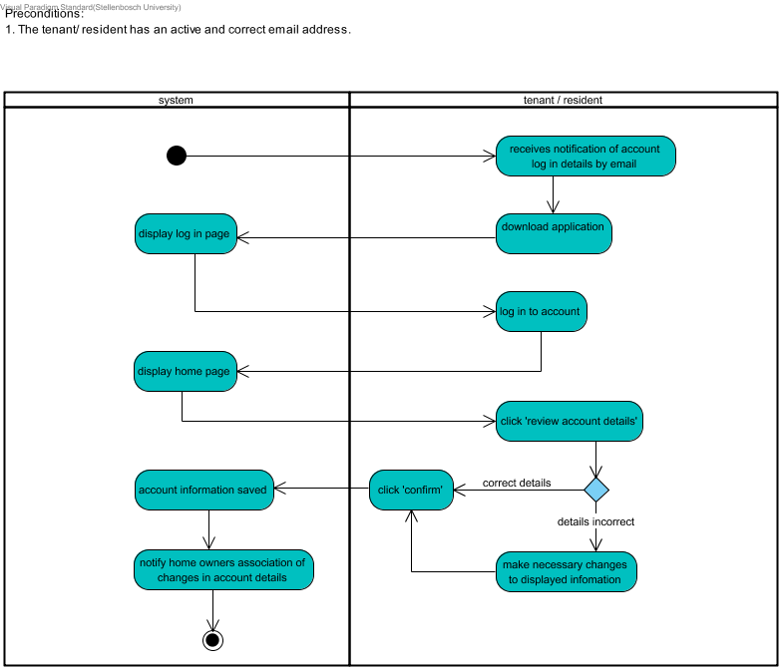

#### Macintosh HD:Users:sashazee:Desktop:Screen Shot 2017-08-09 at 20.42.54.pngMacintosh HD:Users:sashazee:Desktop:Screen Shot 2017-08-09 at 20.40.05.png

#### 

#### 

#### 

#### 

#### 

#### 

#### 

#### 

#### 

#### 

#### 

#### 

#### 

#### 

#### 

#### 

#### 

#### 

#### 

#### 

#### 

#### 

#### 

#### Edit Account

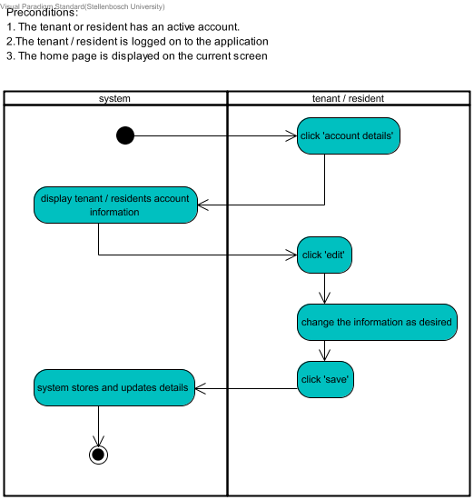

#### Macintosh HD:Users:sashazee:Desktop:Screen Shot 2017-08-09 at 20.40.18.pngMacintosh HD:Users:sashazee:Desktop:Screen Shot 2017-08-09 at 20.40.05.png

#### 

#### 

#### 

#### 

#### 

#### 

#### 

#### Load Tenants Balances

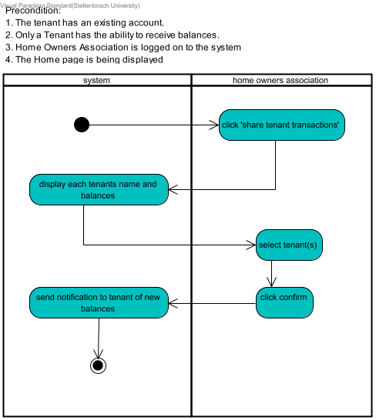

#### Macintosh HD:Users:sashazee:Desktop:Screen Shot 2017-08-09 at 20.36.20.pngMacintosh HD:Users:sashazee:Desktop:Screen Shot 2017-08-09 at 20.33.10.png

#### 

#### 

#### 

#### 

#### 

#### View Balances

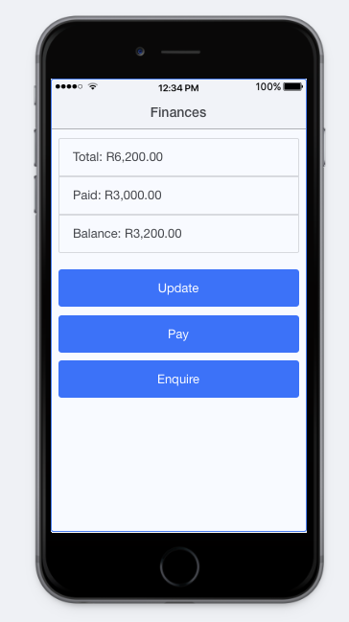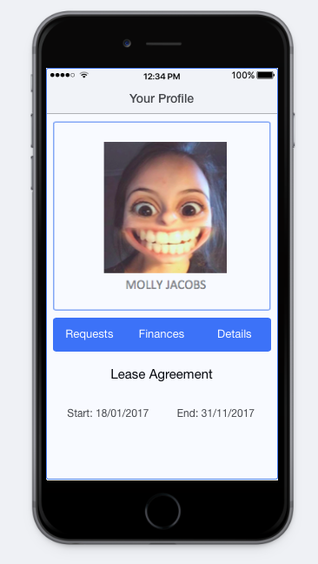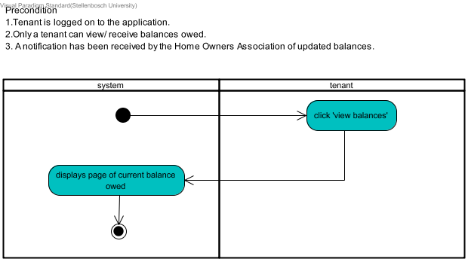

#### Delete Resident/Tenants Account

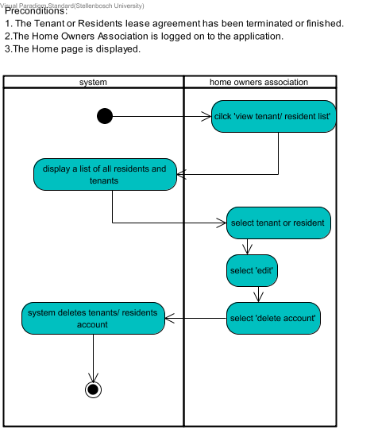

#### 

#### 

#### 

#### 

#### 

#### Macintosh HD:Users:sashazee:Desktop:Screen Shot 2017-08-09 at 20.13.40.pngMacintosh HD:Users:sashazee:Desktop:Screen Shot 2017-08-09 at 20.14.39.png

#### 

#### 

#### 

#### 

#### Receive General Notifications

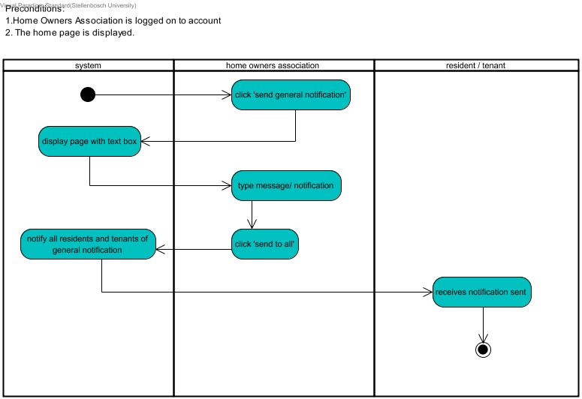

#### Macintosh HD:Users:sashazee:Desktop:Screen Shot 2017-08-09 at 12.28.27.pngMacintosh HD:Users:sashazee:Desktop:Screen Shot 2017-08-09 at 12.29.03.png

#### 

#### 

#### 

#### 

#### 

#### 

#### 

#### 

#### 

#### 

#### 

#### 

#### Macintosh HD:Users:sashazee:Desktop:Screen Shot 2017-08-09 at 20.07.07.png

#### 

#### 

#### 

#### 

#### 

#### 

#### 

#### 

#### 

#### 

#### View Home Owners Associations Contact Details

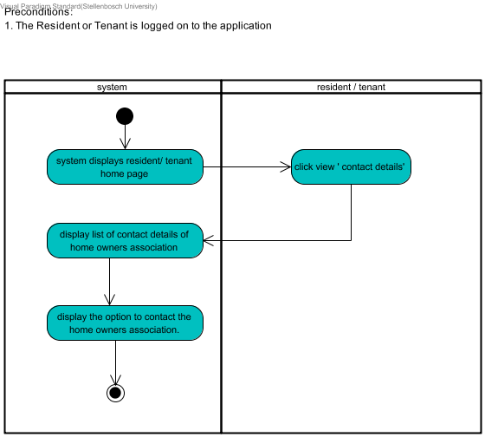

#### Macintosh HD:Users:sashazee:Desktop:Screen Shot 2017-08-09 at 02.03.01.pngMacintosh HD:Users:sashazee:Desktop:Screen Shot 2017-08-09 at 01.47.01.png

#### 

#### 

#### 

#### 

#### 

#### 

#### Raise an Enquiry

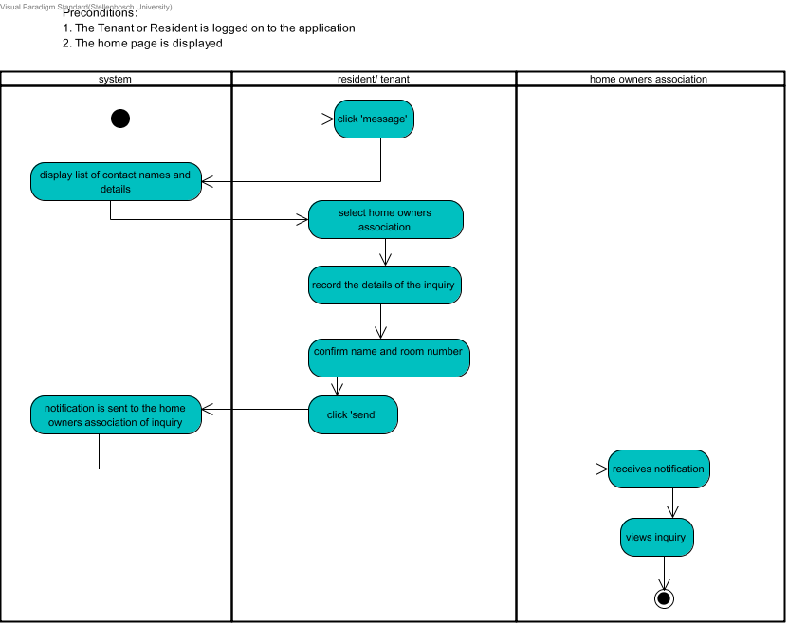

#### Macintosh HD:Users:sashazee:Desktop:Screen Shot 2017-08-09 at 01.04.43.pngMacintosh HD:Users:sashazee:Desktop:Screen Shot 2017-08-09 at 00.16.17.png

#### 

#### 

#### 

#### 

#### 

#### 

#### 

#### 

#### 

#### 

#### 

#### 

#### Macintosh HD:Users:sashazee:Desktop:Screen Shot 2017-08-09 at 01.27.15.pngMacintosh HD:Users:sashazee:Desktop:Screen Shot 2017-08-09 at 01.13.19.png

#### 

#### 

#### 

#### 

#### 

#### 

#### 

#### 

#### 

#### Handle Enquiry

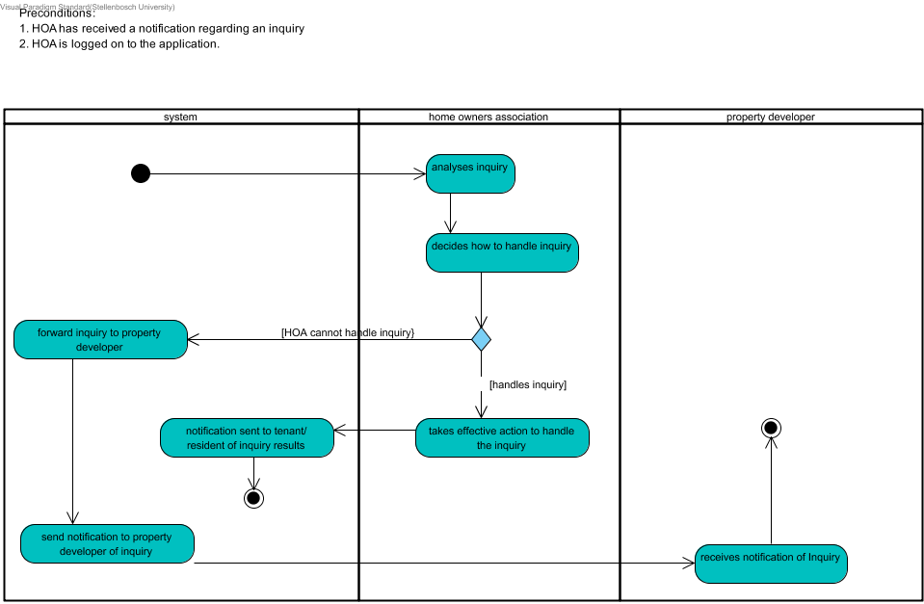

#### Passes On Enquiry

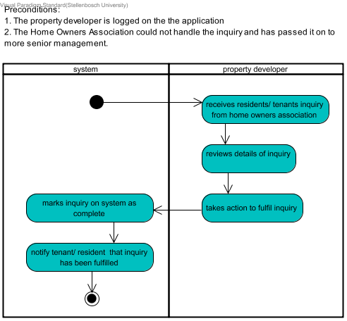

#### 

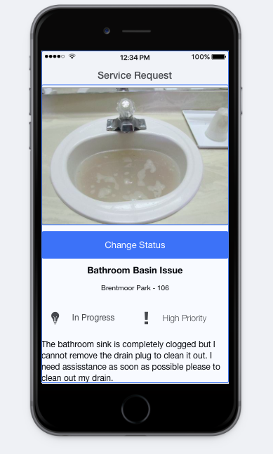

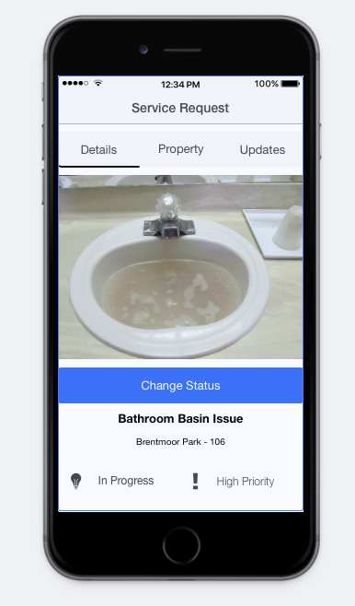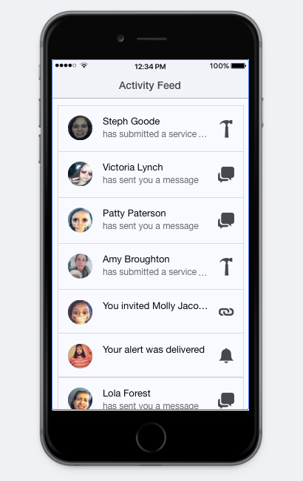

#### Macintosh HD:Users:sashazee:Desktop:Screen Shot 2017-08-08 at 09.14.07.pngMacintosh HD:Users:sashazee:Desktop:Screen Shot 2017-08-08 at 09.14.43.png

#### 

#### Macintosh HD:Users:sashazee:Desktop:Screen Shot 2017-08-08 at 10.16.58.pngMacintosh HD:Users:sashazee:Desktop:Screen Shot 2017-08-08 at 09.15.06.png

#### 

#### 

#### 

#### 

#### 

#### 

#### 

#### 

#### 

#### 

#### Create Notice

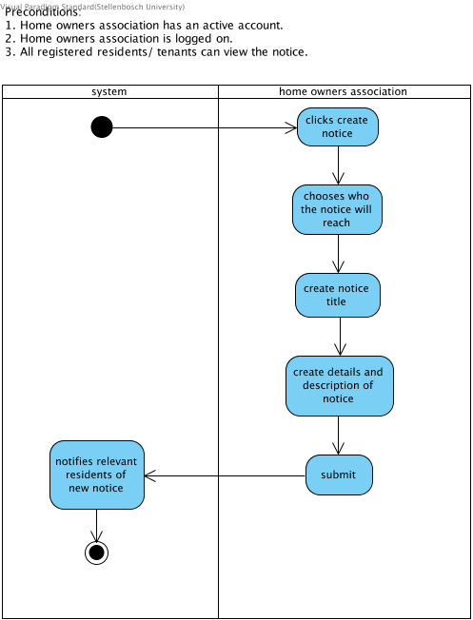

### Macintosh HD:Users:sashazee:Desktop:Screen Shot 2017-08-11 at 15.08.42.pngMacintosh HD:Users:sashazee:Desktop:Screen Shot 2017-08-11 at 15.08.18.png

### 

### 

### 

### 

### 

### 

### 

### 

### 

### 

### 

### 

### 

### 

### 

### 

### 

### 

### 

### 

### 

### **Report Problem**

#### Lodge Support Ticket

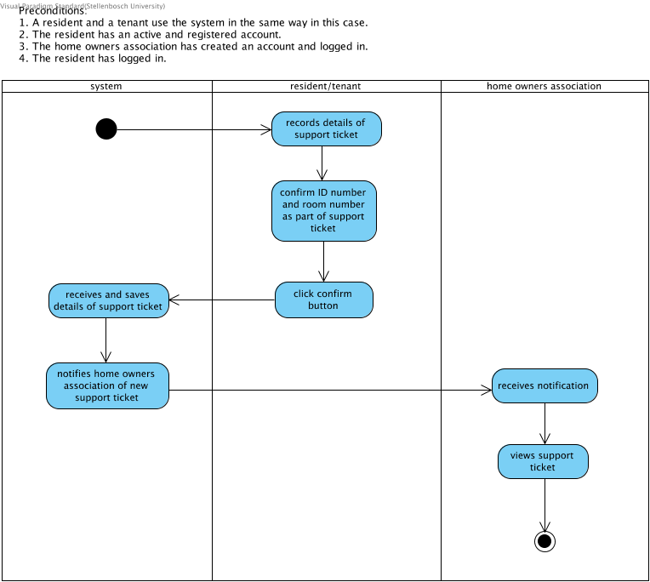

#### Macintosh HD:Users:sashazee:Desktop:Screen Shot 2017-08-11 at 15.13.42.pngMacintosh HD:Users:sashazee:Desktop:Screen Shot 2017-08-11 at 15.14.06.png

#### 

#### 

#### 

#### 

#### 

#### 

#### 

#### 

#### 

#### 

#### 

#### 

#### 

#### 

#### 

#### 

#### 

#### 

#### 

#### 

#### 

#### 

#### 

#### Categorize Support Ticket

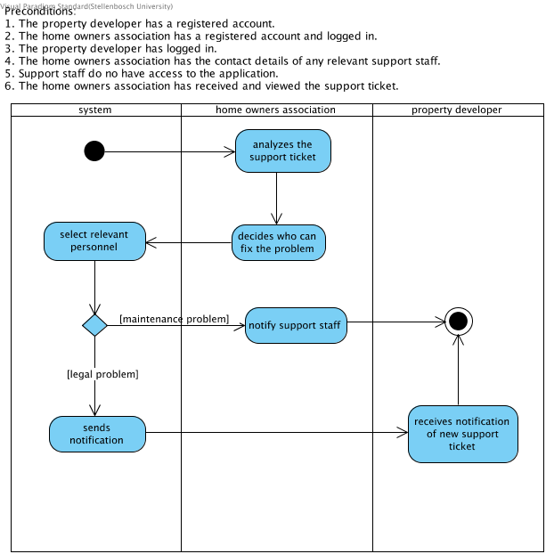

#### Receive Support Ticket

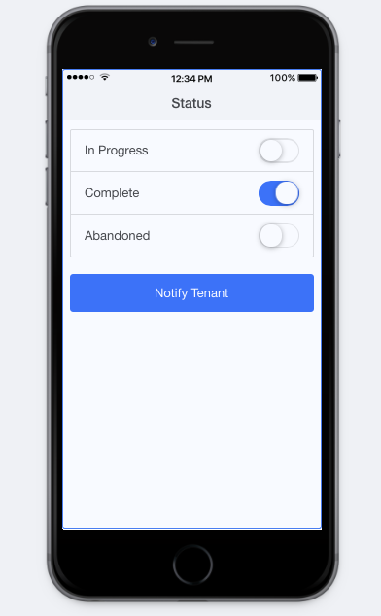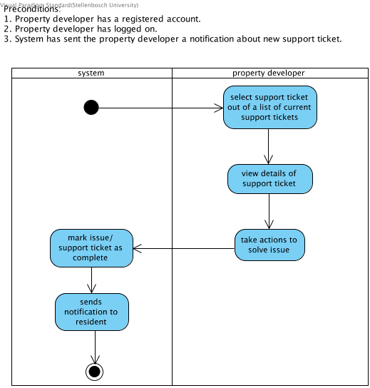

#### Inform of Maintenance Date

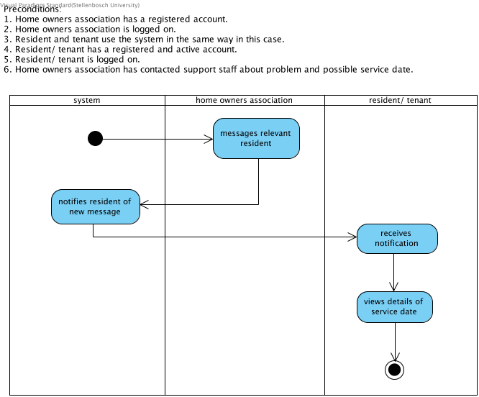

#### Confirm Date

### 

### 

### 

### 

### 

### 

### **Wireframe Text Descriptions**

**Home Page**

This is the first page of the system that the resident or tenant sees once they have logged on to the system. This page has a picture and the name of the relevant apartment block the tenant or resident resides in. This page contains buttons that link the user to a list of units in the block, the chat forum, a map and some other details.

**Forum Page**

This is the forum which is public and can be viewed by any user who has an active account. The user is given the option to create a forum on this page and can also see a list of the current chat forums.

**Create Forum Page**

This page appears after the users selects the create forum option on the forum page. On this page, there is a list of potential forum members that the user can select to be part of the forum.

**Create Group Page**

This page appears after the user has selected which persons they want to be a part of the forum. The user then creates a name for the forum and clicks the confirm button.

**Sign-Up Page**

On this page, the Home Owners’ Association creates a profile for a resident or tenant. The first step is to select whether the person is a tenant or resident. Although these two actors are very similar and treat the system the same in most cases, there are some small differences. Therefore their profile must state which one they are. After this step, the Home Owners’ Association can fill in all the other required information and then click the submit button. An account is then created for a resident or tenant and they can log in using their details. Their password will be emailed to them once the account is created. They will be able to change this password on the system once they have logged in.

**Login Page**

This page simply requires the user to enter their email address and password in order to access all the system’s features. The system with then confirm if these two details are correct and if so, the user will be granted access.

**Your Profile Page**

This page is seen as a summary page for the resident or tenant to view their profile and make any changes. This page contains their profile picture, full name and lease start and end date. From this page, the user can also access other portals of the system such as requests page, finances page and details page. There is a button on this page that links the users lease agreement, where it is visible by the user.

**Account Details Page**

A resident or tenant has access to this page once they have logged in with the correct login details. This is where the user can change any of their personal details such as name, email address, contact number, password and profile picture. Besides changing details, the user can also choose options of which of their details they want to be visible to others using the system. This is done by using a slider button for show email, show number and show room number. This feature is added to ensure that the user has privacy options. Once the user has filled in all details and is happy with the options selected, they can click the save button. All the updated details are then saved onto the system.

**Tenant Transactions Page**

This page can only be accessed by the Home Owners’ Association. It is used by them to view and update each member's current balance and send the details of the member’s balance to that particular member. The first step is to select the member’s name from a list of available members. Once this is done, the Home Owners’ Association views selected member and clicks confirm and the system will send a notification to the tenant or resident.

**Finances Page**

This page is used by the tenant to view their current balance details. The balances that they can view is the total amount, the amount paid and the current amount still owed. After they have viewed these balances, they can decide whether to update, pay or enquire about their balances. The physical transaction is completed externally and not on the application.

**Delete Account**

This page is used by the Home Owners’ Association when they wish to delete a resident or tenants account. They can view the relevant person’s account details and then click the red delete button to permanently remove this person’s account.

**Apartment Units Home Page**

This is the home page that the Home Owners’ Association can see. They use this page when they want to view certain aspects of that specific apartment block. The options from this page are to view the social forum, send a notification, view the current occupation of the units and view the map.

**New Notification Page**

The Home Owners’ Association uses this page to create a new notification that will be sent to all the relevant residents or tenants. The Home Owners’ Association can create the message in the specified text box.The HOA will then confirm who they are wanting to send this notification to, whether it is to all residents and tenants or a specific group of individuals.. Once they have selected that option, the system will send the created notification to all relevant users.

**Activity Feed Page**

This page displays a summary of all the notifications or messages received. From this page, the user selects which message or notification to view. The residents, tenants and HOA can see any messages or notifications. The Home Owners’ Association can see all notification as well as see if their notifications were successfully sent and any other notification regarding other users reporting problems.

**Contact Details Page**

The system allows the resident or tenant to view the Home Owners’ Association’s contact details. The user might want to send them documents via email or contact them via a phone call, therefore this page adds value to the users experience. The page displays options for the user to call or private message the relevant Home Owners’ Associate. The information that this page displays in the home owners associations address, cell number, email address and fax number.

**Messages Page**

This page contains all current chats. The user can see the names of all current chats as well as see if the message has been received and if it has been read. The user can also search for a chat by typing in the relevant person's name in the search space provided. To go to the next page, create chat, one clicks the button with a plus sign in the top right-hand corner.

**Start New Chat Page**

On this page, one can see a list of people with whom one can send a message to and start a chat with. To send a message, the user with click the button with a plus on it next to the person’s name with whom they want to talk.

**New Message Page**

This page appears after a user has selected who they want to send a message to. This page contains spaces in enter the subject of the message and the content of the message. The user then confirms that this message is going to the correct person, in the correct apartment block and room number. They can then click send.

**View Service Request Page**

This is the page where the home owners association can view all the details of the maintenance problem that was logged by one of the residents or tenants. There is tabs at the top of the page to navigate to the details of the problem, which apartment block it is in and any updates regarding this request. There is a picture and a description of the maintenance problem and the block and room number it is in is stated. Each maintenance issue has its priority noted in order for the most important ones to be attended to first. The issue also has a status, which can be changed by the home owners association. The status is changed by clicking the change status button, which opens a new page.

**Change Status of Service Request Page**

This page includes the options to change the status of a particular service request. The options include ‘In Progress’, ‘Complete’ and ‘Abandoned’. The user selects whichever one is relevant in the case and clicks notify tenant. The point of having a status for each maintenance problem is that this gives the resident of tenant an idea of when the maintenance issue will be solved.

**Chat Interface Pages**

These pages show how the chat interface between two users of the system would work. The user would have already selected the other user with whom to message. There is a bar at the bottom of the screen where the resident or tenant would type in their desired message. They will then click the send button. Following this, the user can receive replies and and messages and then reply to them.

**Your Requests Page**

This page shows a summary of all the requests currently in the system for that tenant or resident. The page shows the title of each request as well as the status of that request. From this page, the user clicks the ‘New Request’ button to log a new support ticket.

**New Ticket Page**

It is here where the resident or tenant will log all the details of a new support ticket. It has spaces where the user can include all details as well as upload a picture of the fault. The user must select if it is a maintenance problem, a legal problem or an other type of problem. The user also has to decide what is the priority of the problem. After they are happy with support ticket, they click submit.

**More Page**

On the system, the resident or tenant can do many things, therefore there is a section where they can choose what they want to do. It is a summary page of all the other actions that can be performed besides those shown on the user’s homepage.

**Create Advertisement Page**

The user will post all the details of their advertisement here. The details that are required are a title, a picture and a description. The user clicks submit to send the advertisement to the home owners association for approval.

**Create Notice Page**

This page is only viewable by the HOA. It is here where they can create a notice that can be seen by whomever they select. They can select either residents and tenants, the property developer or everyone to be able to see this notice. The other details that are filled in on this page are the title of the notice and it’s description. By clicking submit, the system will notify the relevant users of the new notice and they will then be able to view it.

# 

# 

# 

# 

# 

# 

# State Machine Diagrams

## **Support Ticket**

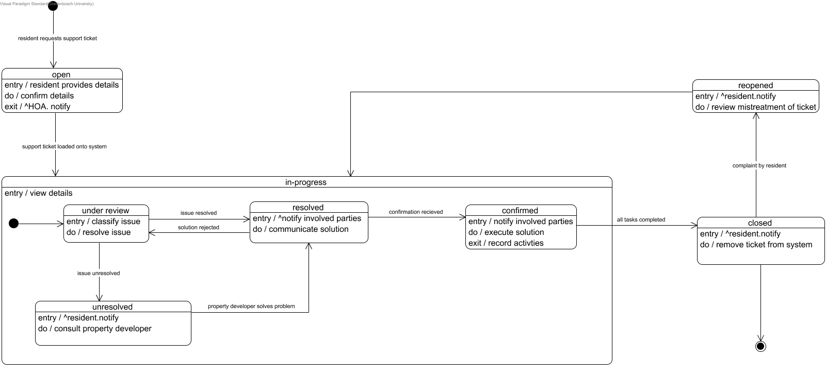

## **User Profile**

# 

# 

# 

# 

# 

## **Notice**

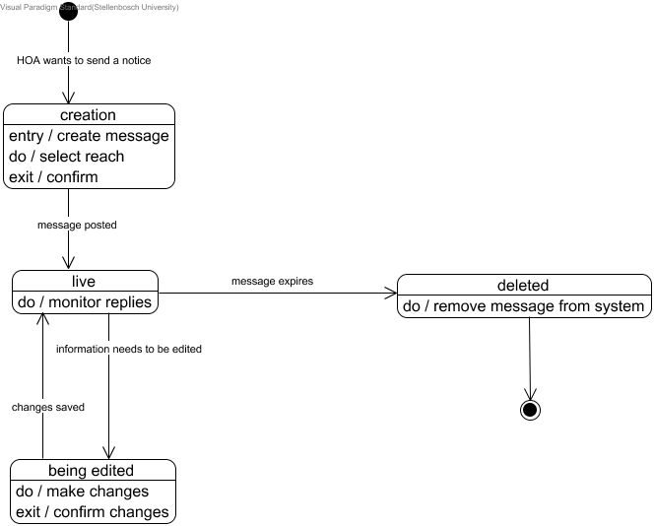

# 

# 

## **Enquiry**

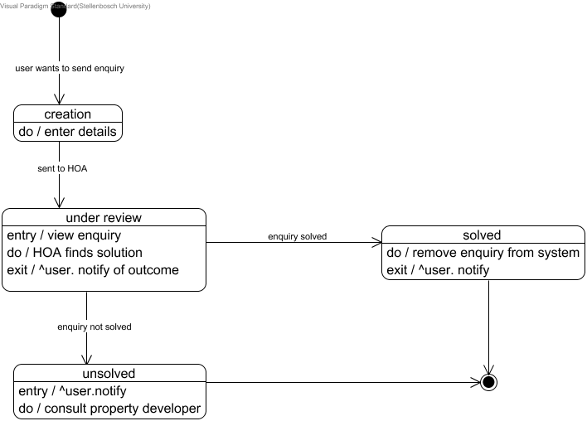

# 

# 

# 

# 

# Class Diagram

## **Assumptions**

A user can only have one account/profile

A support ticket can only be linked to one tenant/resident

Only one public social chat interface exists

There is no limit to how many advertisements residents/tenants can post

All managers in the HOA can view and deal with each support ticket

A tenant can be a resident but they do not have to be

# 

# 

# 

# 

# 

# 

# Deployment Plan

## **Training**

All users of the application need to be trained. These include:

* The HOA
* Property developer
* Residents and tenants

The HOA and property developer will have a training session together where the developers will demonstrate how to use the application. The residents and tenants will receive a document via email upon registration containing instructions of how to use HomeRun.

## **Conversion**

The HOA is currently using an informal, temporary system of communicating with residents and tenants while they wait for the application to be developed. It is a paper based system and involves email and phone calls as contact mediums. This temporary system was created with the HOA so has not been operating for long and is therefore not possible to base a system on it. There is therefore no conversion to make from an old system and there is no old data to load onto the system. All user data is new and will be loaded onto the system manually, when user accounts are created. Data regarding property details and other aspects will be loaded by the development team during the implementation phase.

## **Scheduling of Jobs**

The property developer is responsible for adding and removing HOA users to the system and has the most authority in the application. Once HOA managers have their profiles, they are responsible for adding and removing residents and tenants to the system. Technical work is required by the HOA when using HomeRun to operate the buildings, so it is important that they get trained properly.

## **Rollout**

Batch notification emails will be sent to all residents, tenants, members of the HOA and the property developer two weeks before the application is set to release. They will receive another email notification containing instructions when the application is ready.

## **End-User Procedures**

As mentioned above, end users will receive a notification email telling them that the application is ready. This email will contain a link allowing them to download HomeRun. The property developer will create all the HOA member’s accounts first. The HOA members will then receive an email with a temporary password which they can log in with and then change at a later stage. The HOA can then begin adding users to the system using the same process that was just mentioned. Once each user has an active account, they will receive an email containing detailed instructions on how to use the application.

## **Post Implementation Follow Up**

After HomeRun has been in use for three months, the development team will check up on the progress and operations of the system. They will do this by asking the property developer and HOA how the system is working, if it is satisfying their requirements and what problems have emerged. A few residents and tenants can also be consulted for the same issues. Corrective action will then be undertaken to fix and enhance the system.

# Sign-Off

|  |
| --- |
| This system conforms to agreed specifications of the systems requirements, aims and objectives. |
| **Signature of Property Developer** |
| (Date/ Signature) |
| **Signature of IT developer** |
| (Date/ Signature) |
| **Signature of Home Owners Association** |
| (Date/ Signature) |

short dash

# Glossary

**JAD**

* Joint Application Development. A process used for developing computer based systems that involves interaction between users of the system and the developers (Beal, 2017).

**BRD**

* Business Requirements Document. A document containing the details of the business solutions and requirements for the project.

**HTML**

* Hypertext Markup Language. A standard language used for creating web pages.

**CSS**

* Cascading Style Sheet. This is a programming language used to style pages developed in HTML.

**SQLite**

* This is a programming language that will be used to manage the databases involved with this system. The source code for SQLite is free to use and is on a public domain.

**Overhead Costs**

* These are costs incurred by running this company.

**Constraint**

* A limitation or restriction.

**Stakeholder**

* A person, group or organisation that can affect or be affected by the organisations actions, objectives or policies.

**Resident**

* One who resides in the property.

**Tenant**

* A person who occupies land or property rented from a landlord.

**Login**

* A username and password that allows a person to access a mobile device, user account or computer system.

**RACI**

* Is an acronym that stands for responsible, accountable, consulted and informed. A RACI chart is a matrix of all the activities or decision making authorities undertaken in an organisation set against all the people or roles. (Morgan, 2008)

# 

# 

# External References

Beal, V. 2017. *What is Joint Application Development? Webopedia Definition*. [online] Available at: http://www.webopedia.com/TERM/J/Joint_Application_Development.html [Accessed 17 Aug. 2017].

Podeswa,H. 2009. *The Business Analyst's Handbook*. Boston: Course Technology. 1-433.

Royston Morgan. 2008. *HOW TO DO RACI CHARTING AND ANALYSIS: A PRACTICAL GUIDE*. [ONLINE] Available at: <https://www.projectsmart.co.uk/how-to-do-raci-charting-and-analysis.php>. [Accessed 17 August 2017].